**Working with Ubuntu Customization Kit to create a VMware view Live-CD.**

Original article from:

<http://geekyprojects.com/ubuntu/build-your-own-custom-ubuntu-livecd/>

Thank you Pablo Garcia

With parts from:

<http://www.bonusbits.com/main/HowTo:Create_an_Ubuntu_Live_CD_with_Vmware_View_Client>

Thank you bonusbits

1) Download an image of your favorite Ubuntu version. I decided to go with the latest Ubuntu 12.04.

2) Install Ubuntu Customization Kit on your host computer.

3) Start Ubuntu Customization Kit by clicking on Applications -> System Tools -> Ubuntu Customization Kit.

On Ubuntu 12.04 it shows an error after selecting language, just upgrade everything and it should work.

4) Select all desired language packs and the language you want to use as default for your liveCD.

It only worked with en for me.

5) Select the desktop environment, for this example we will use gnome which is the one that comes with Ubuntu 10.10.

Select gnome

6) Select the Ubuntu Image you just downloaded.

7) Name your live-CD.

8) Do you want to customize your CD manually during building? Select “yes”.

9) Do you want to delete all windows-related files from CD? Select “yes” so that you can have more space on you live CD available for loading programs.

10) Select Hybrid USB / CD image? YES

At this point, UCK will start unpacking the files from the ISO image and putting them on a temp directory. We are going to modify these files using the host computer’s terminal, ~~the synaptic~~ and the consoles provided by UCK.

After UCK is finished unpacking the files, the following window will come up:

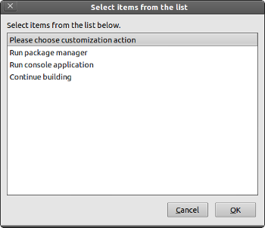

~~Package manager: This is basically the same as synaptic, with it you can add or remove any program you wish from the liveCD. If you can’t find the program you are looking for, you probably need to add the source; do this by clicking on Settings -> Repositories on your package manager menu~~. Package manager doesn’t work with 12.04 it will probably be removed in the next version of UCK.

Console application: This is the same as your Ubuntu terminal.

.

Continue Building: Self-explanatory. Before clicking on this option, make sure you have made absolutely all changes since by clicking this, UCK will start building the final ISO.

Installing or removing programs

UCK Package Manager is not working on 12.04 you can install aptitude for package viewing and uninstall packages with sudo apt-get autoremove and install with sudo apt-get install command.

**Install VMware View Client**

1. Select **Run console application**

This is a shell that is in the build image environment. Not your Ubuntu system you are working in.

1. Add software repositories that include View Client

Edit Apt-Get Source List with:

nano /etc/apt/sources.list

Add repository links (needs both)

deb http://us.archive.ubuntu.com/ubuntu/ oneiric universe

deb http://archive.canonical.com/ubuntu oneiric partner

exit and save your changes

1. Update Apt-Get with the repository data

apt-get update

1. Optional step but good to follow: Upgrade current packages

apt-get upgrade

1. Install View Client package

apt-get install vmware-view-client

**Install Other Packages** **Uninstall Unwanted Packages**

Remove “Welcome” Window and “Install Ubuntu” Icon From Desktop

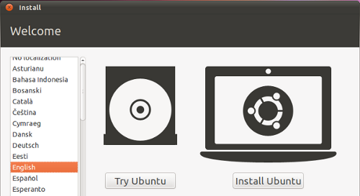

If you are going to use the disk as a LiveCD, then the initial “Welcome” window becomes useless. To remove it do the following:

On Ubuntu Customization Kit, ~~open UCK Package Manager and remove Ubiquity.~~ Open UCK terminal and run the command: sudo apt-get autoremove ubiquity

This will remove the “Install Ubuntu” icon on the desktop as well.

Remove “Samples” Folder

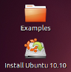

This one is very easy. On the host computer, open a terminal window and type the following (*To do this, UCK must have the LiveCD image uncompressed on the host computer’s hard drive. otherwise liveCD temp files won’t exist*):

sudo nautilus ~/tmp/remaster-root/etc/skel

There you will find the “Examples” folder, delete it and you are done. To remove “Install Ubuntu 12.04” please read the previous section.

Create Desktop Shortcuts on Your LiveCD

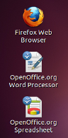

Run liveCD with the ISO image you are going to use as model for your custom LiveCD using Virtualbox or other virtualization program, then create all desktop shortcuts you wish to have on you customized liveCD. Once you have all your shortcuts created, transfer them to you host (your actual computer, not the virtual one). I usually do this by opening a shared folder in the host computer and trasfering everything from the virtual machime to the shared folder in the host through the network.

To customize the desktop on your LiveCD you will have to create a custom folder for it. To do this, open a terminal window on your current operating system (not on UCK’s console window) and type the following command: (*To do this, UCK must have the LiveCD image uncmpressed on the host computer’s hard drive. otherwise liveCD temp files won’t exist*):

sudo nautilus ~/tmp/remaster-root/etc/skel

There, create a folder called Desktop, (make sure to capitalize the D) and drag the icons you created in your previous liveCD to this new folder.

**Method 2**

1. Browse remaster root user directory

cd ~/tmp/remaster-root/etc/skel

Create a Desktop directory (it is case sensitive):

Sudo mkdir ~/tmp/remaster-root/etc/skel/Desktop

Sudo cd ~/tmp/remaster-root/etc/skel/Desktop

1. Create file **vmware-view-client.desktop**

I used the command: sudo touch ~/tmp/remaster-root/etc/skel/Desktop/vmware-view-client.desktop

1. Add content to file

#!/usr/bin/env xdg-open  
[Desktop Entry]  
Encoding=UTF-8  
Type=Application  
Icon=vmware-view-client-vmware  
Exec=vmware-view –fullsrceen –serverURL=https://server-ip-address  
Categories=Application;Network;  
Name=VMware View Client

1. Set execute permissions on file (very important step don’t forget it)

chmod 0755 vmware-view-client.desktop

**Configure View Client to Launch Automatically**

In the folder ~/tmp/remaster-root

(It is visible after starting UCK and exported the iso image) run

Sudo mkdir –p ~/tmp/remaster-root/etc/skel/.config/autostart

Sudo touch ~/tmp/remaster-root/etc/skel/.config/autostart/Vmview-client.desktop

Sudo nano ~/tmp/remaster-root/etc/skel/.config/autostart/Vmview-client.desktop

Paste this:

[Desktop Entry]

Type=Application

Icon=vmware-view-client-vmware

Exec=vmware-view –fullsrceen –serverURL=https://server-ip-address

Categories=Application;Network;

Name=VMware View Client

**Hack view client EULA accept**

Just run the command from the host’s machine terminal (iso must be extracted):

Sudo nano ~/tmp/remaster-root/usr/bin/vmware-view

Commend all entries except LICENSE, touch, exec . Your file should look like the following:

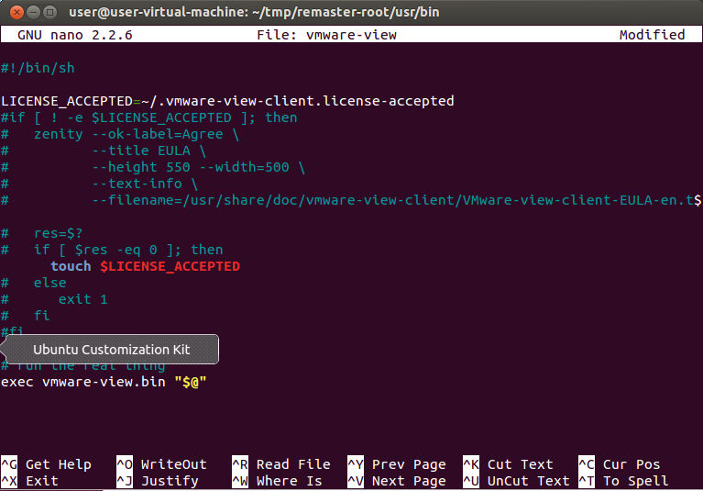

**Change GNOME’s Background** (haven’t used it, I don’t know if it works)

Generally background files are located in /usr/share/backgrounds. Open this directory by issuing the following command on your host computer’s terminal (*To do this, UCK must have the LiveCD image uncompressed on the host computer’s hard drive. otherwise liveCD temp files won’t exist*):

sudo nautilus ~/tmp/remaster-root/usr/share/backgrounds

Paste your background image in there, making sure to set the wallpaper to the “native” resolution you want displayed. I made mine 1024 X 768 because that is the native resolution of the monitors that I would be using. If you paste the background file using the name “warty-final-ubuntu.png” and replace the one currently there, you can probably skip the following instructions:

Changing files pointing to a different path and background filename (optional)

To change the files to point from the original filename to your background filename, open the “ubuntu-wallpapers.xml” and the “16_ubuntu-wallpapers” files, issuing the following commands on the host computer: (*To do this, UCK must have the LiveCD image uncompressed on the host computer’s hard drive. otherwise liveCD temp files won’t exist*)

sudo gedit ~/tmp/remaster-root/usr/share/gnome-background-properties/ubuntu-wallpapers.xml

and

sudo gedit ~/tmp/remaster-root/usr/share/gconf/defaults/16_ubuntu-wallpapers

once you have those two files open, look for the following string:

/usr/share/backgrounds/warty-final-ubuntu.png

Change “warty-final-ubuntu.png” to your own background file name.

**Make sure everything is OK! Exit console and hit continue building. After iso is created you can burn it or make a bootable usb with LiLi usb creator.**

**Create an Ubuntu Live CD with Vmware View Client**

<http://www.bonusbits.com/main/HowTo:Create_an_Ubuntu_Live_CD_with_Vmware_View_Client>

**Purpose**

This article gives the steps to create an Ubuntu bootable ISO image with the Vmware View Client. This can then be burned to CD or setup on a USB thumb drive and used to launch a Vmware View session from boot or in Windows.

Example based on Ubuntu Desktop 11.10 i386 Build System VM and ISO.

**Create Ubuntu Build System**

*Skip this section if you already have an Ubuntu desktop available.*

* Install Ubuntu on a physical system or as a VM to use for building the image
  + This will not be cloned or used for the ISO image so don't worry about any specific settings
* Get the latest updates using the Update Manager

**Setup Ubuntu Build System**

* Install '**Ubuntu Customization Kit (UCK)'** with apt-get or **Ubuntu Software** application
* Download the latest Ubuntu Desktop ISO on the Ubuntu Build system.
  + The Downloads directory is fine

**Build Image**

**Unpack ISO**

1. Launch **Ubuntu Customization Kit**
2. Select Language
3. Browse to Ubuntu install ISO
4. Select **Yes** to use customization terminal
5. Select **Yes** ...
6. Set Name and Location of build ISO file

**Install View Client**

1. Select **Run console application**
   1. This is a shell that is in the build image environment. Not your Ubuntu system you are working in.
2. Add software repositories that include View Client
   1. Edit Apt-Get Source List

vi /etc/apt/sources.list

* 1. Add repository links

deb http://us.archive.ubuntu.com/ubuntu/ oneiric universe

deb http://archive.canonical.com/ubuntu oneiric partner

1. Update Apt-Get with the repository data

apt-get update

1. Ugrade currrent packages

apt-get upgrade

1. Install View Client package

apt-get install vmwaver-view-client

**Install Other Packages** **Uninstall Unwanted Packages**

**Configure View Client to Launch Automatically**

*Method 1*

1. Launch **Startup Applications** GUI

gnome-session-properties

1. Select **Add**
2. Enter name **VMware View Client**
3. Enter **Command**

vmware-view --fullscreen --userName= --domainName=MYDOMAIN --serverURL=https://view.mydomain.com --userName= --protocol=PCOIP --desktopSize=full

**Launch View Client**

1. Launch the View Client to check it's working and except the EULA

vmware-view

**Copy Files to Build Image**

*Method 1*

1. Launch **Nautilus** GUI

nautilus

**Change Background**

*Method 1*

1. Launch **System Settings** GUI

gnome-control-center

1. Select Appearance

**Add Shortcut to Desktop for View**

*Method 1*

1. Create a shortcut on Ubuntu Build System
2. Copy to a shared location
3. Launch **Nautilus** GUI

nautilus

1. Browse to shared location
2. Copy to Desktop

*Method 2*

1. Browse root user directory

cd /root/

1. Create file **vmware-view-client.desktop**
2. Add content to file

#!/usr/bin/env xdg-open  
[Desktop Entry]  
Encoding=UTF-8  
Type=Application  
Icon=vmware-view-client-vmware  
Exec=vmware-view  
Categories=Application;Network;  
Name=VMware View Client

1. Set execute permissions on file

chmod 0755 vmware-view-client.desktop

**Build the ISO**

1. Exit the customization console

exit

1. Select **Continue Building | OK**

**Test the Image**

An easy way to test the ISO image is with Vmware Workstation. If the Ubuntu Build System is a VM just copy the ISO off the VM and boot off it on that Ubuntu Build System VM.

**QUESTION AND ANSWERS**

How do I open Ubuntu Software Center via Terminal?

Open terminal and run

software-center

•Remove Ubiquity package

Sudo apt-get purge ubiquity

Autostart creation

In the folder ~/tmp/remaster-root

(It is visible after starting UCK and exported the iso image)

Sudo mkdir –p /etc/skel/.config/autostart

Sudo touch /etc/skel/.config/autostart/Vmview-client.desktop